Staples Dance Academy
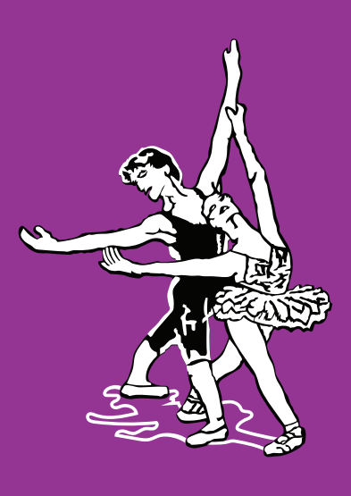
Photography Consent Form

Staples Dance Academy may take photographs or videos of your child while in their dance classes, as part of a dance festival or dance show. These photographs may be used to promote Staples Dance Academy in publications, press articles, promotional material and websites, exclusively for non profit-making purposes.
Name of child (please print): ………………………………………………………………………………
Age: ………………..
I agree to the above named child having their photograph taken as part of their dance class, dance festival or show.
Yes No
I agree to the above named child being filmed in any dance shows and am aware that copies of this film are made into DVD’s that are offered for sale at the Dance Academy.
Yes No
I agree to the above named child having their photograph and name on the CLOSED Facebook page.
Yes No
I agree to the above named child having their photograph on the public Facebook page and the Staples Dance Academy website.
Yes No
I agree to the above named child’s name being published in any associated publicity if required.
Yes No

Parent/Guardian name (please print):………………………………………………………………

Signed: ………………………………………………………Date: ……………………………………….

